As you observe there was no container for gen2 storage

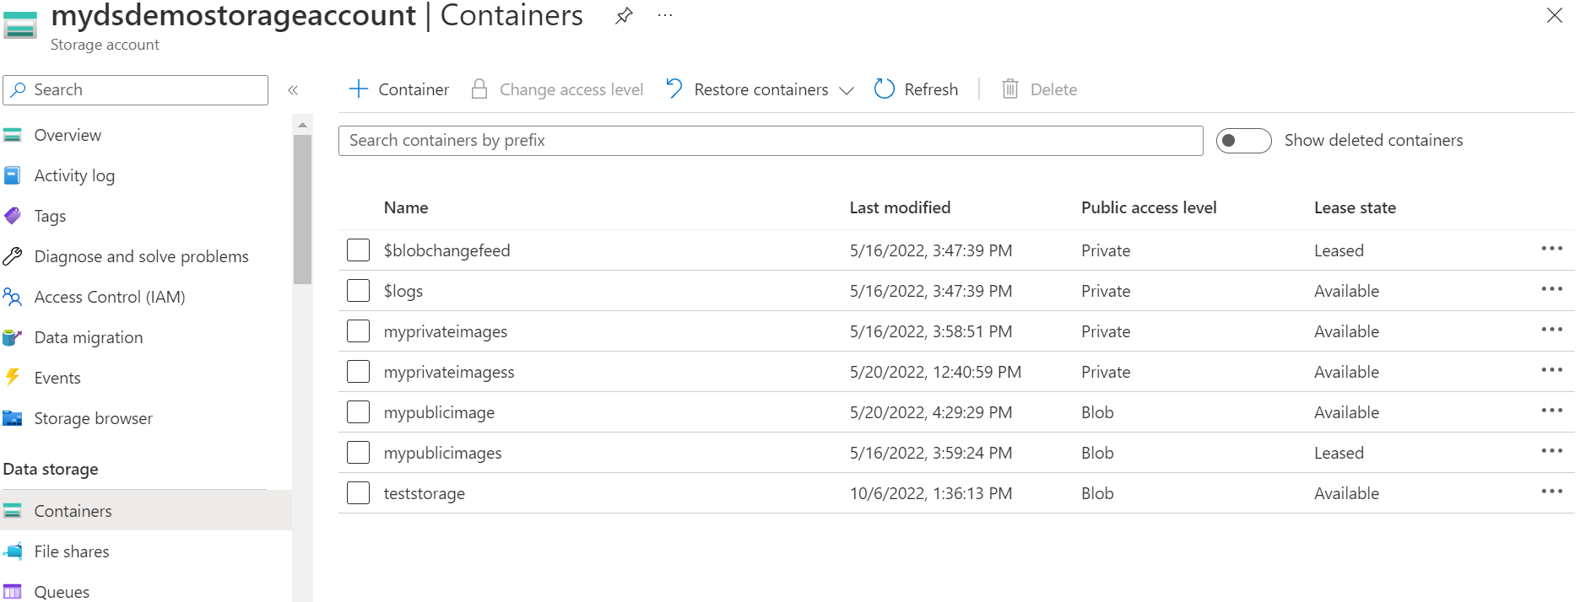

Now will create a azure synapse where we will create gen2 storage and its file storage (container) and in it security you need provide the admin authentation for sql (username and password)

As shown in below screenshots

Review it and create once done you can see the storage account and its container will be present in storage account

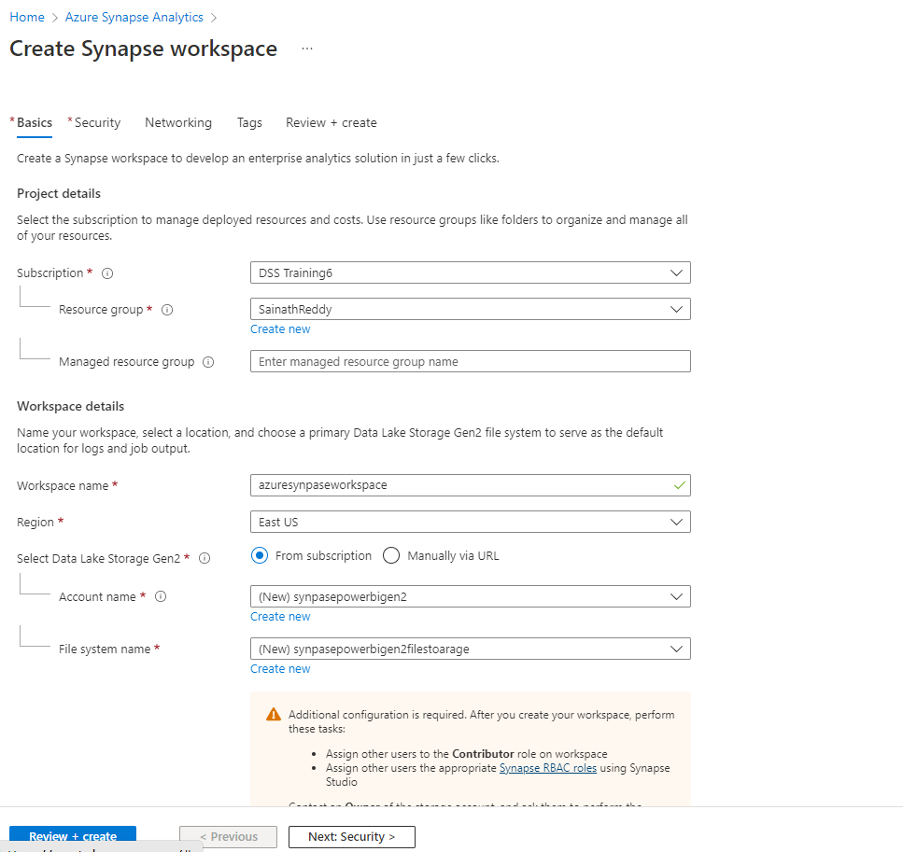

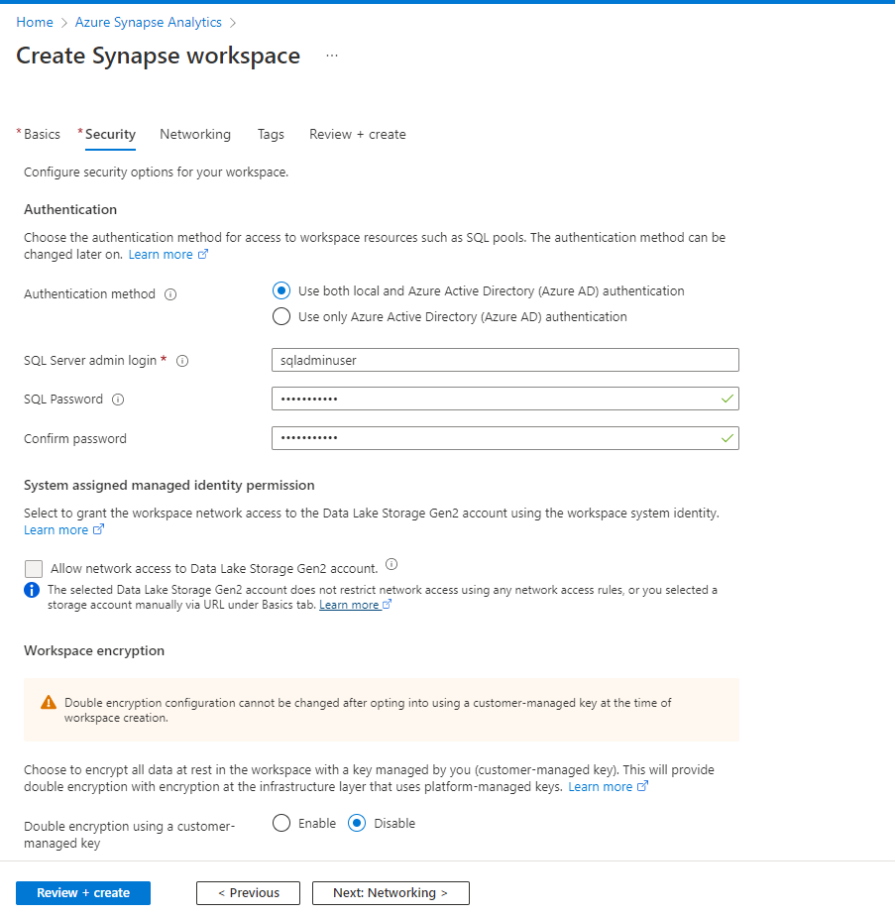

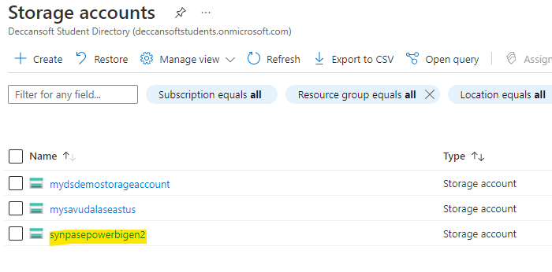

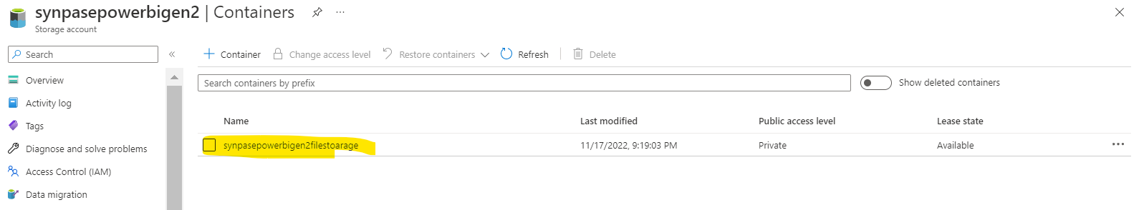

Go to power bi and create the workspace

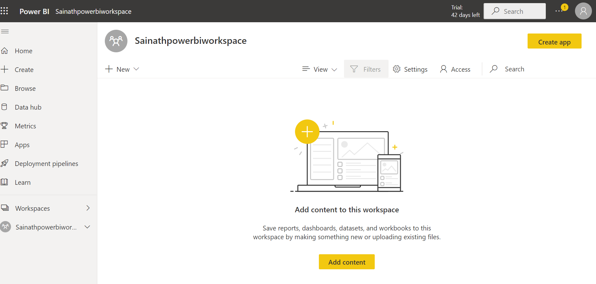

Now we need data to be displayed to database

So for this demo we are taking Cosmo dB to fetch data and load to the Cosmo table

Azure cosmsotable for nonsql is created below

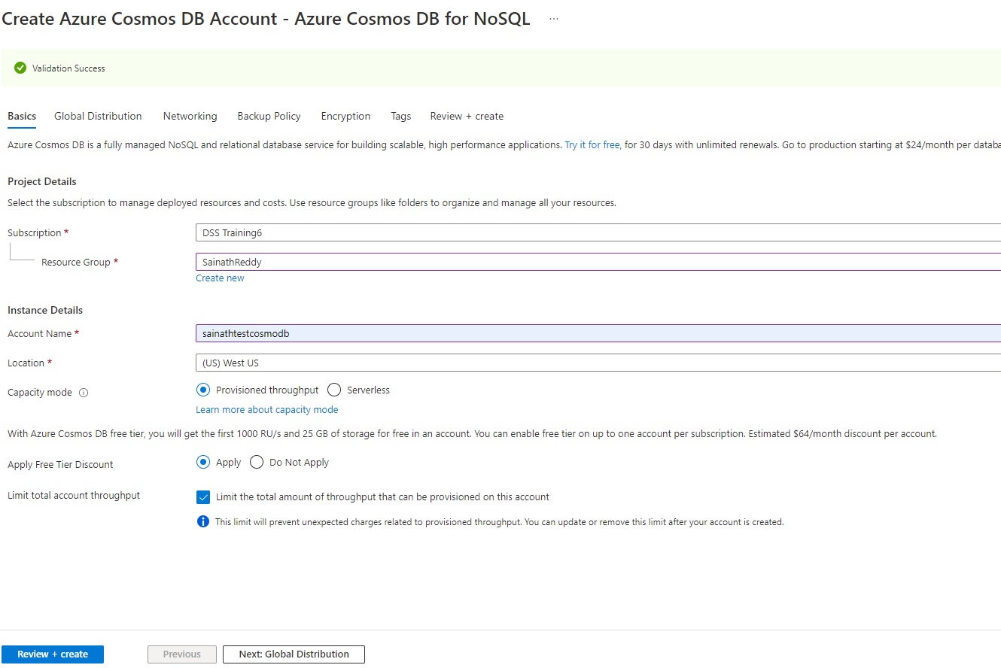

Now the database and its container(table) will be created in cosmsodb with partion key

Then we will enable the synapse for the particular table to use in azure synapse using serverless way

Basic json for demo we can use (I am using partion key here is country for showing in demo)



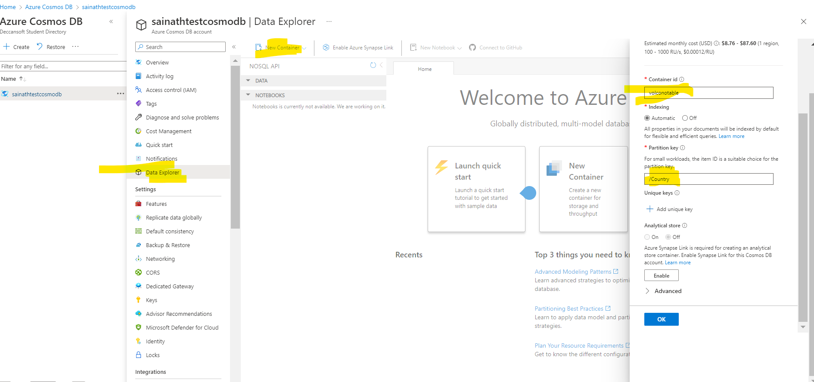

Once the table is create upload aboue json to the container to load all

The data will shown in container

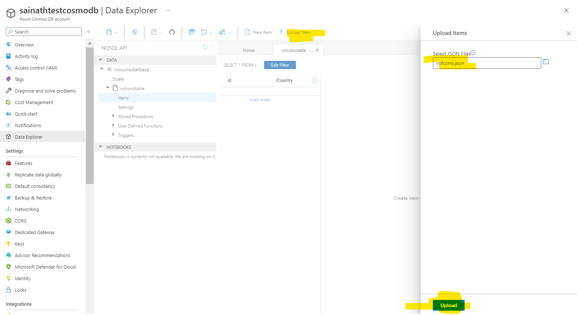

Once uploaded data is shown

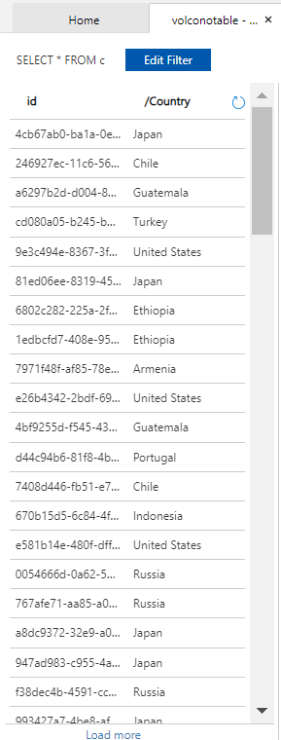

Now enable azure synpae from the cosmodb to the particular table where we need to use azure synpase sql as serverless

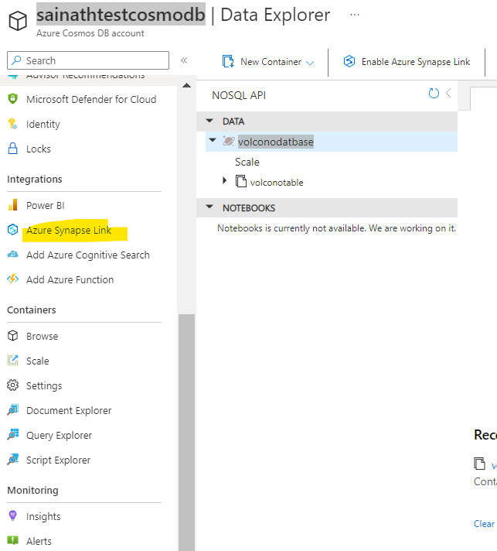

Enable it and select the container

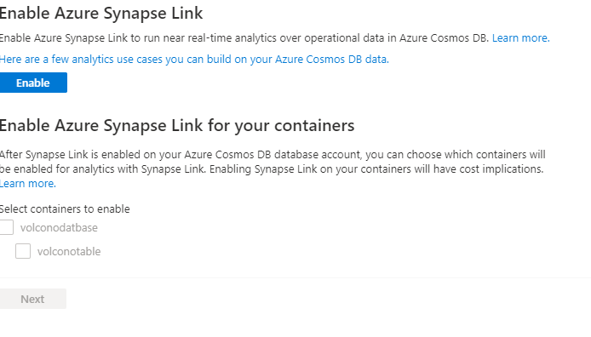

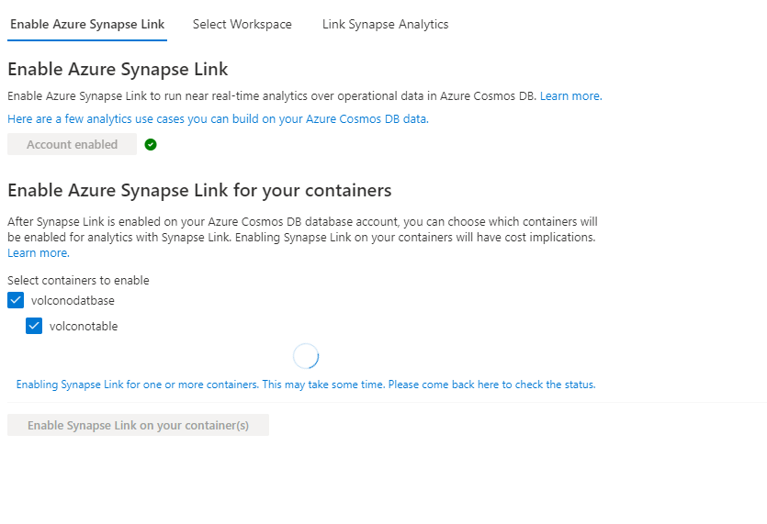

Now we need azure synapse to fetch all Cosmo dB data in powerbi as live with out import model

Now go to azure sypase and open our azure synapse workspace which we have created and openthe workspace for linking the powerbi to azure synpase

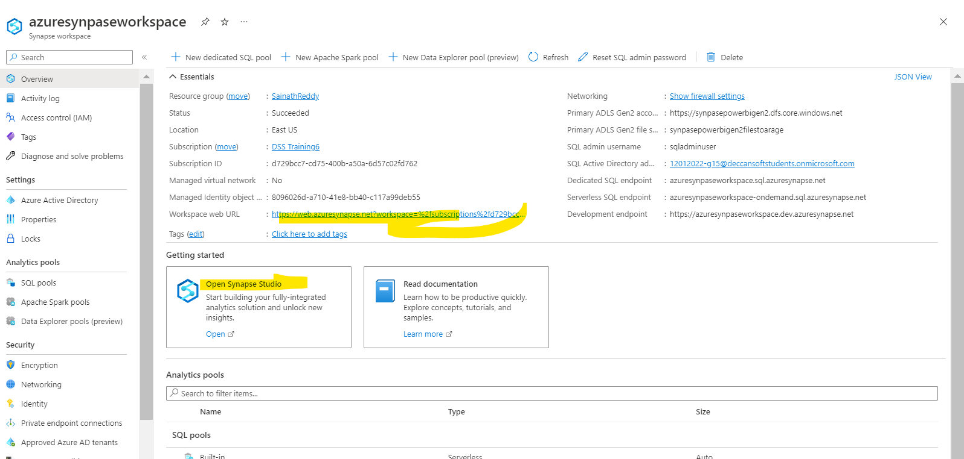

Open the synpase studio

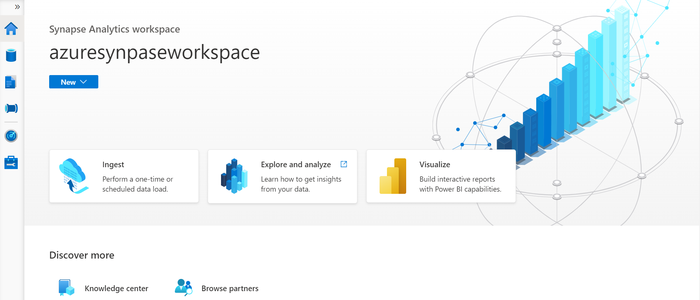

Now go to manage and link powerbi

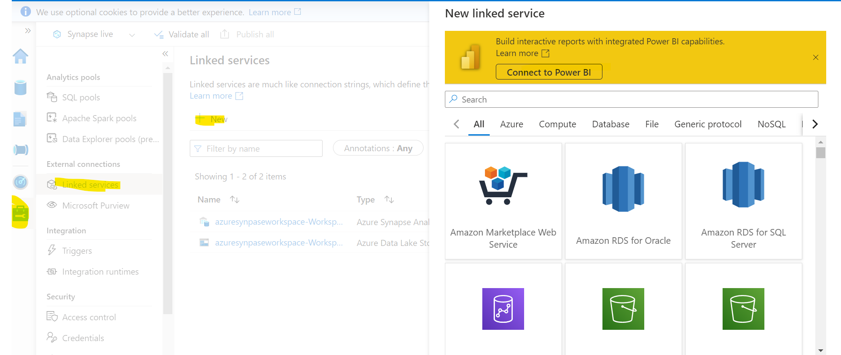

Connet to powerbi

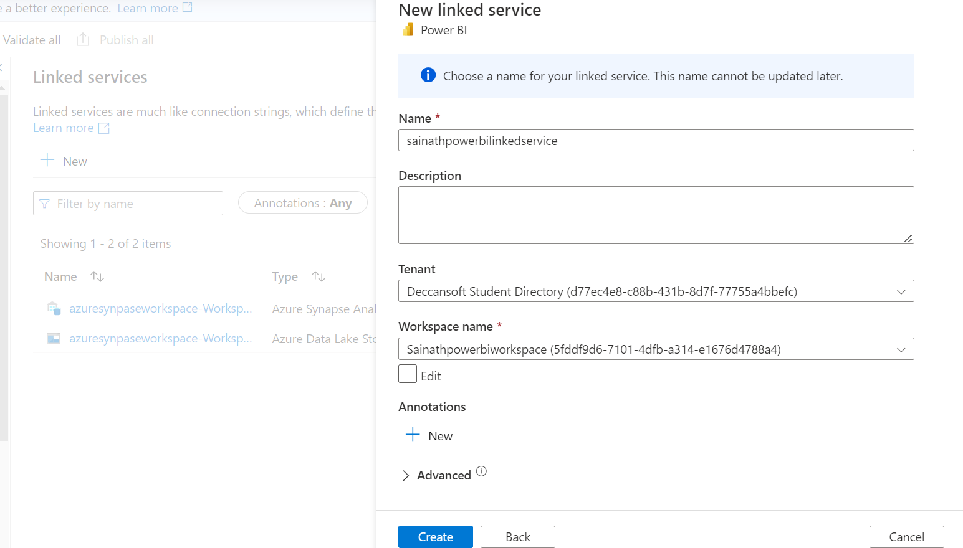

Now you can the workspace name we can see the powerbi workspace automatically because we are in same tenant

And click create once created publish it so the linked service will be ready to use

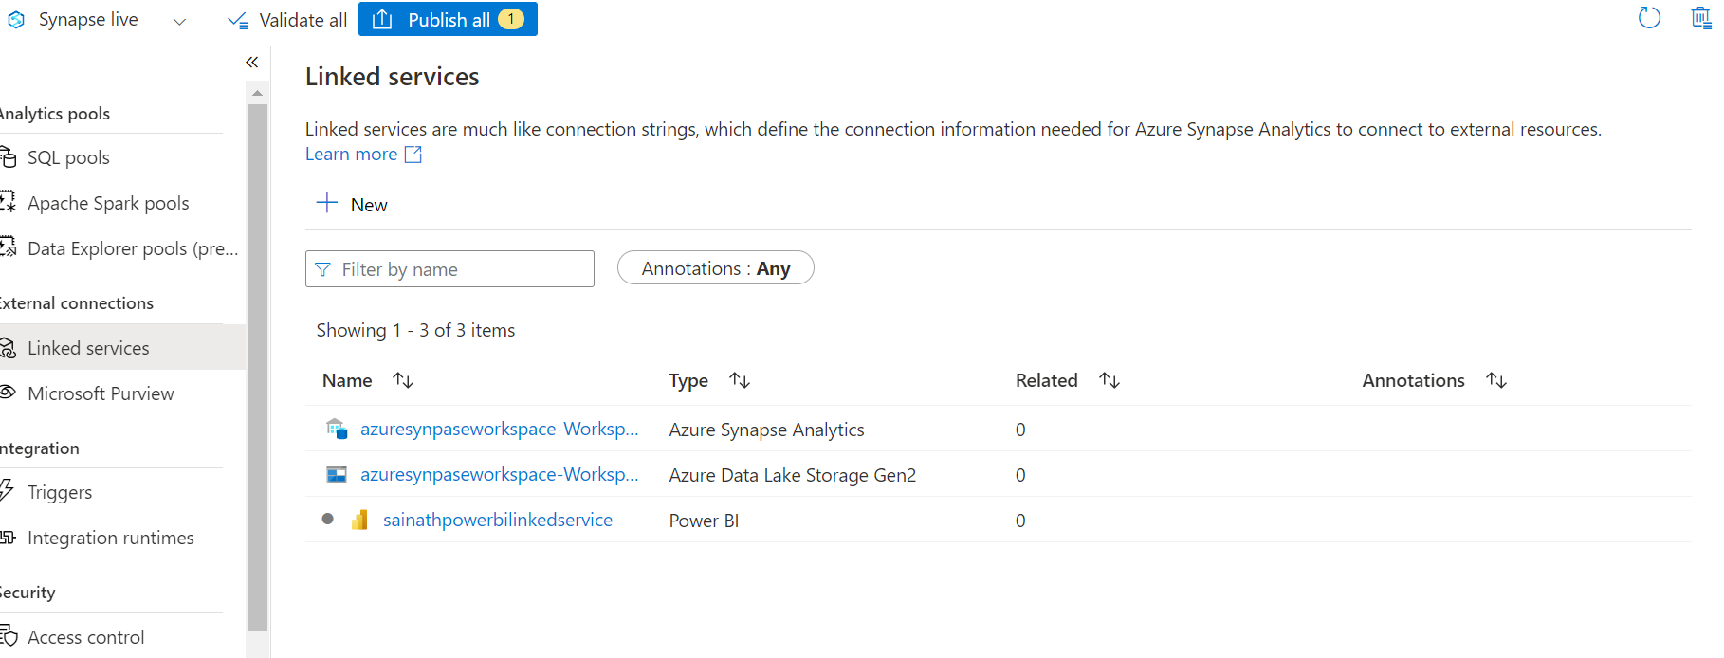

Now we can see th powerbi is connected with azure synpase

No In develop tab we can see our powerbi connectivity

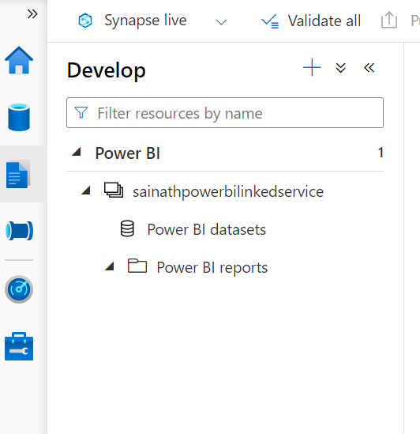

Now we need create sql service serverless

Go to data tab and add sql and select serverless with database name so we can use in powerbi for connectivity

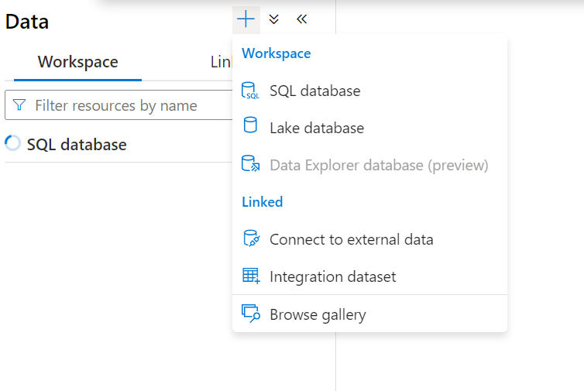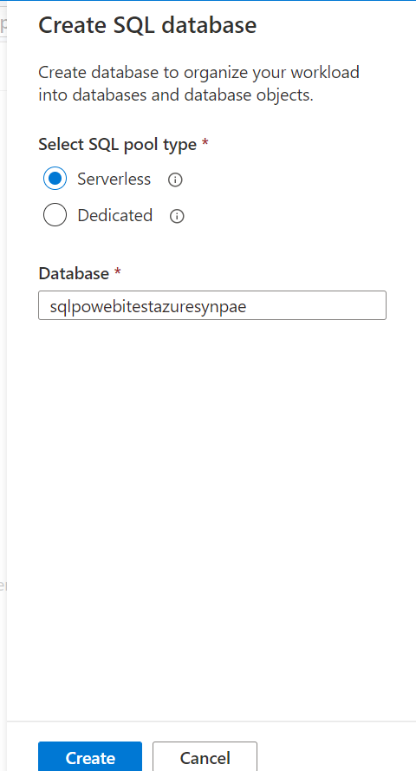

Now you can see our database serverless is been added

Now lets create a database in that sql and view for fetching the data to powerbi

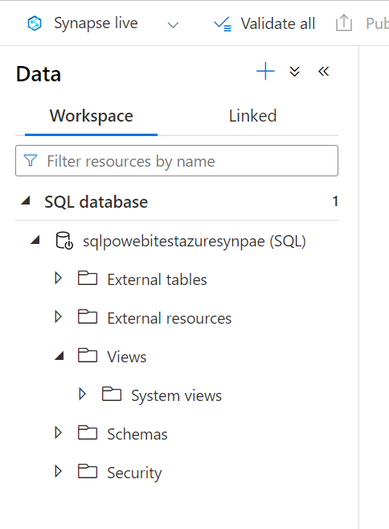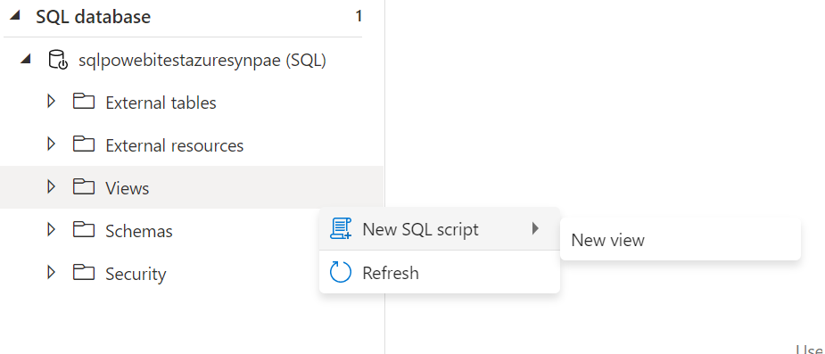

create view powerbitest as

SELECT \*

FROM OPENROWSET(

       'CosmosDB',

       'Account=sainathtestcosmodb;Database=volconodatbase;Key=zYbfStzQ5bnPynBA9rwWIbxlN9QLxBrVFVK6VfWY6bugiJhj0AzP8J2V9dRrULd1duRysFfhzFETACDbg4lH1Q==',

       volconotable) as documents

// in openrowset we provide account as we provide cosmodb

// account name, its datbase and its table name after the key

SELECT TOP (10) \*

FROM [dbo].[powerbitest]

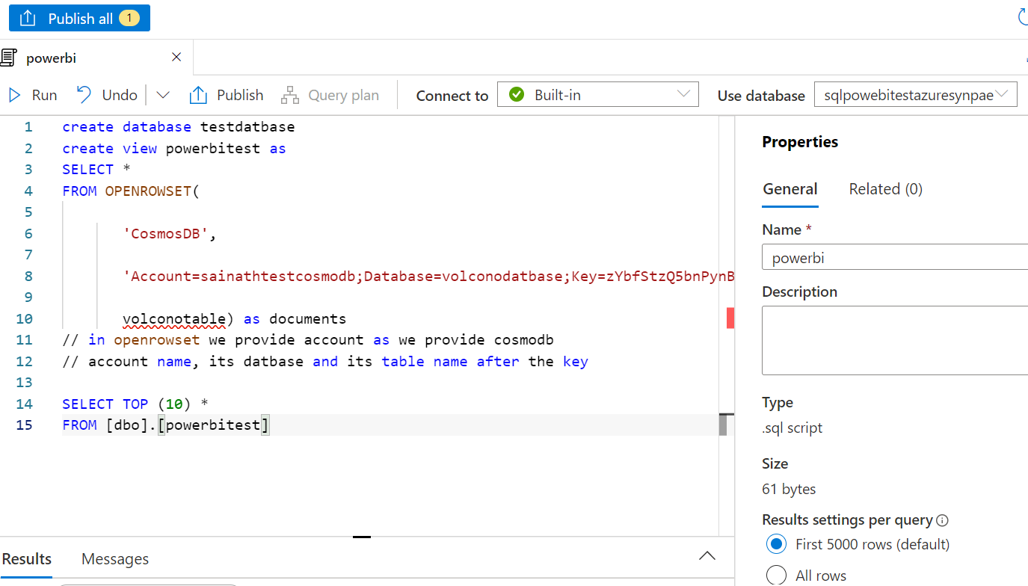

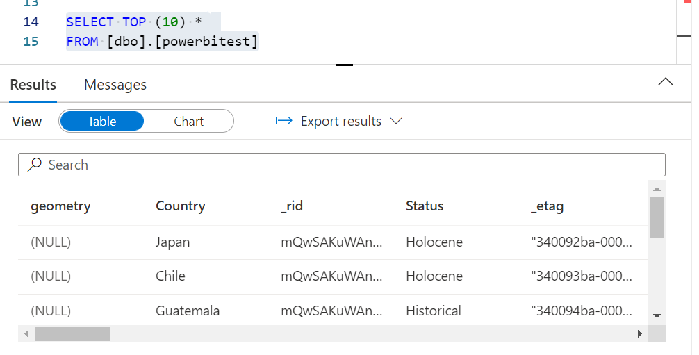

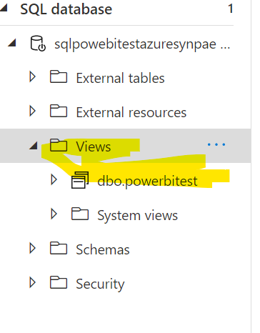

Now come to powebbi desktop and get data more 🡪 azure sql 🡪 connect

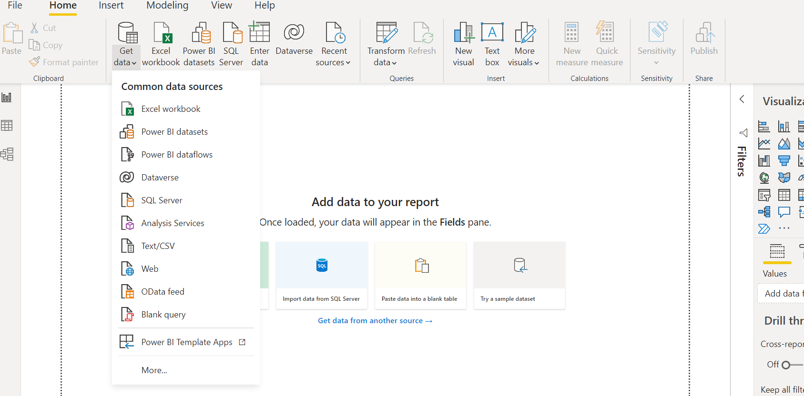

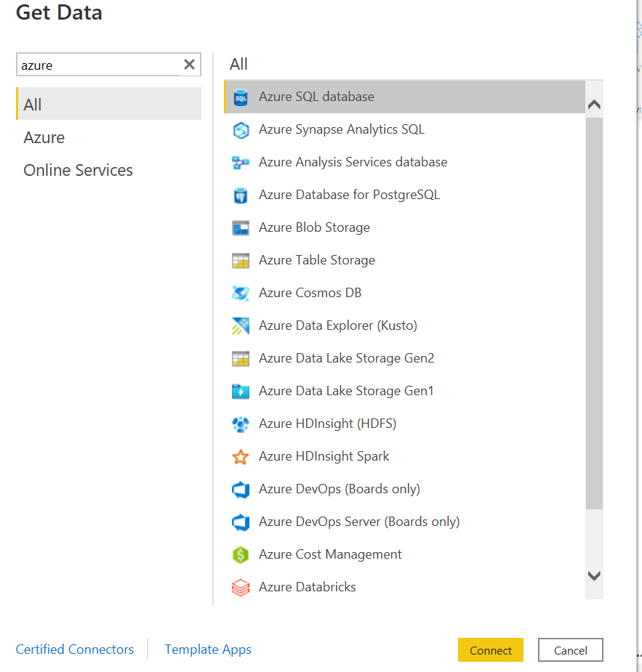

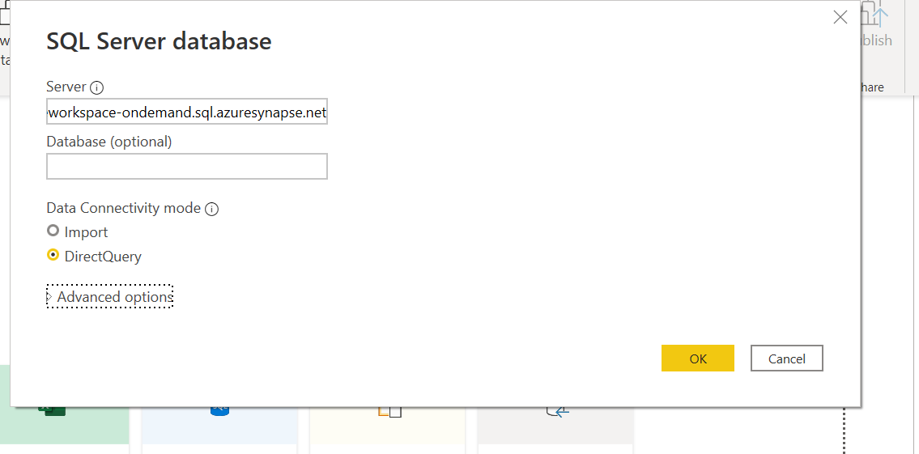

Get server name from azure synapse endpoint

Select direct query as we want it in live data instead of refresh in desktop every time and publish to powerbi app

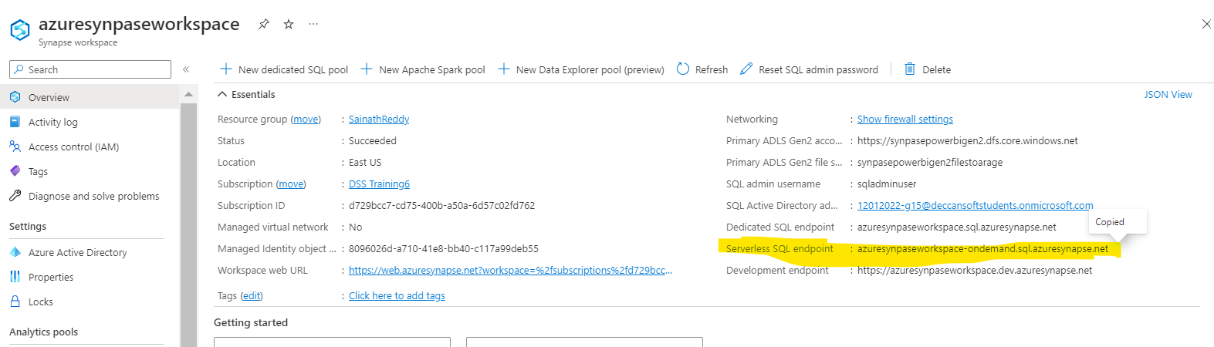

Select database

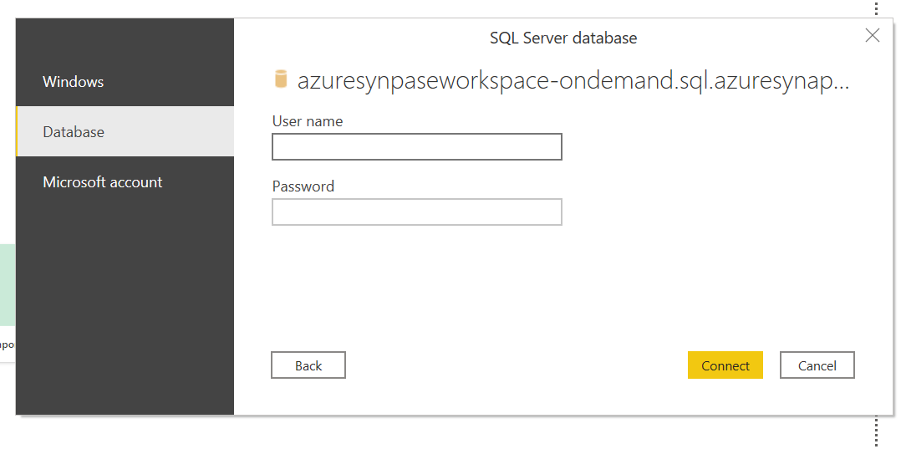

as while creating azure synpase we have created password and username enter those values and click connect

Sqladminuser – and password

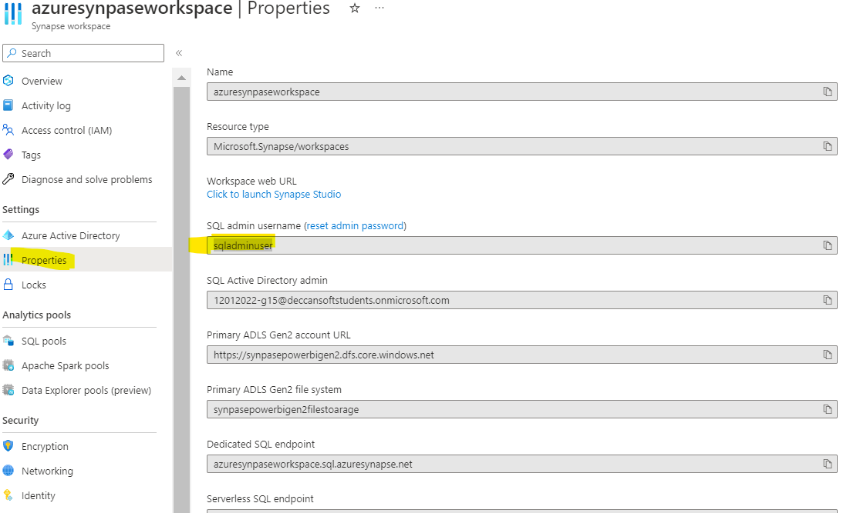

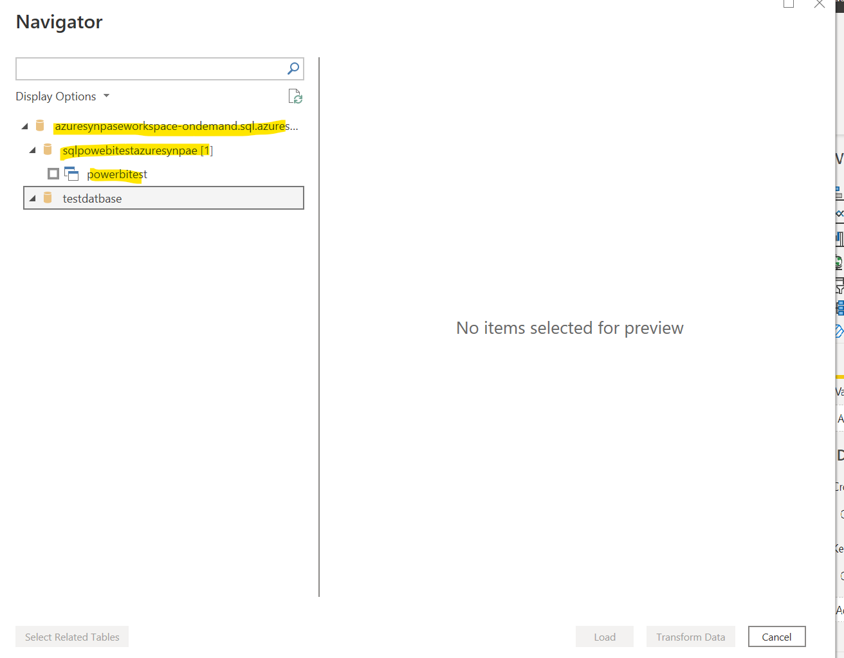

We see the database name and view which we have created select and click load

If you want to transform data to remove you can selet transform data

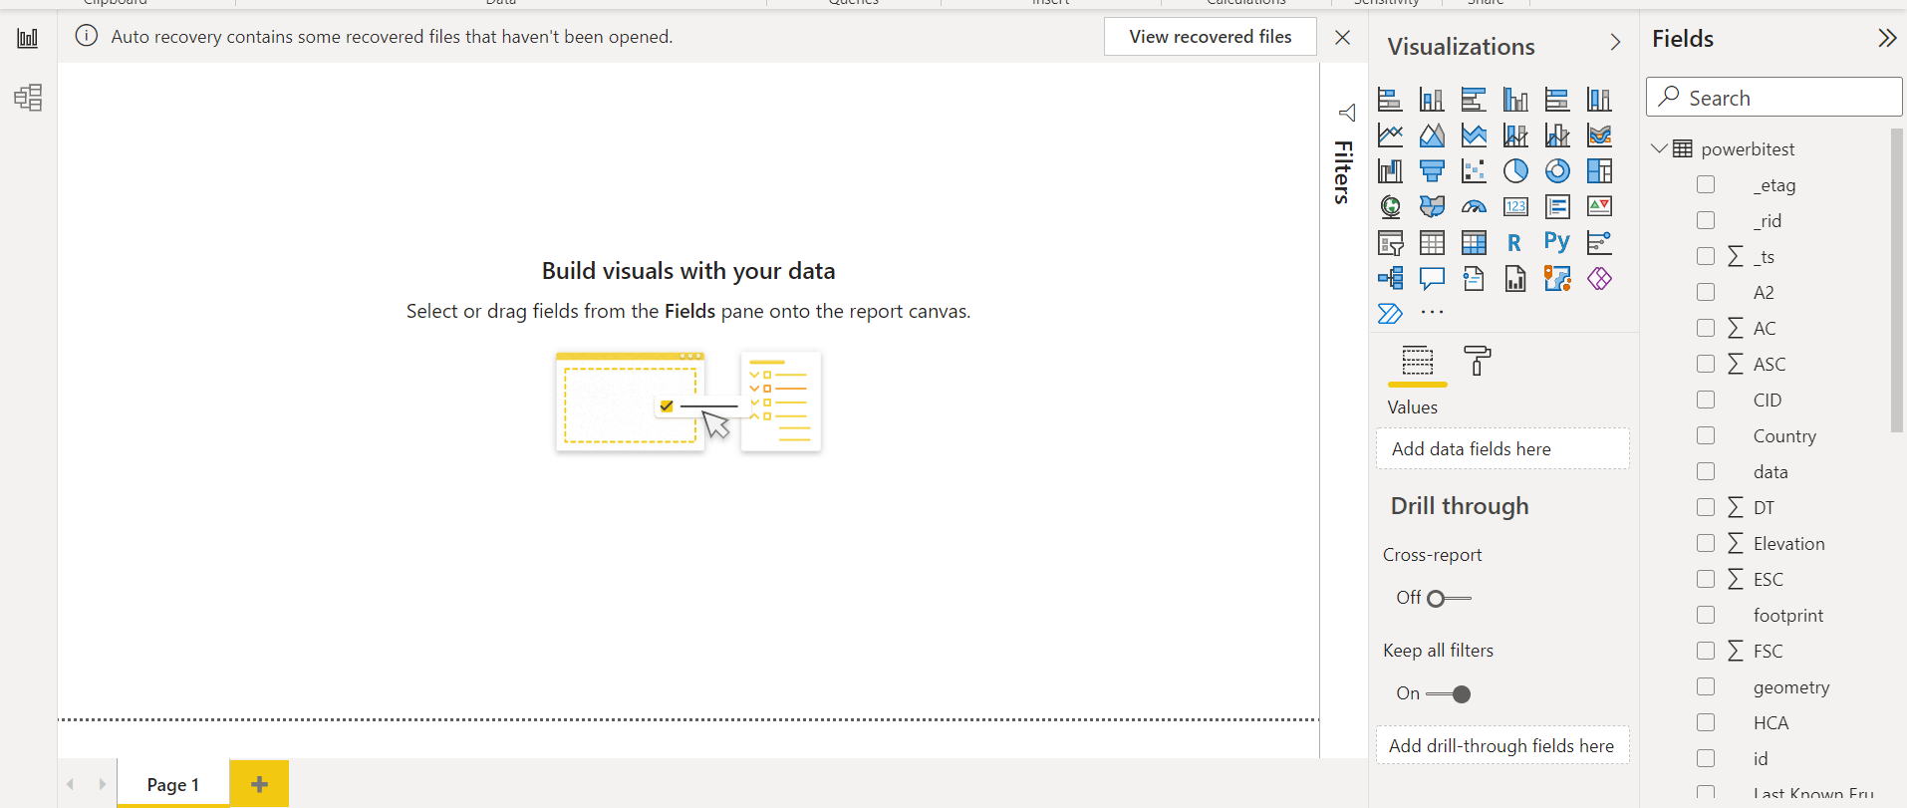

Once load we can see the fields is present at right side

And in right side you see model click to see the model diagram

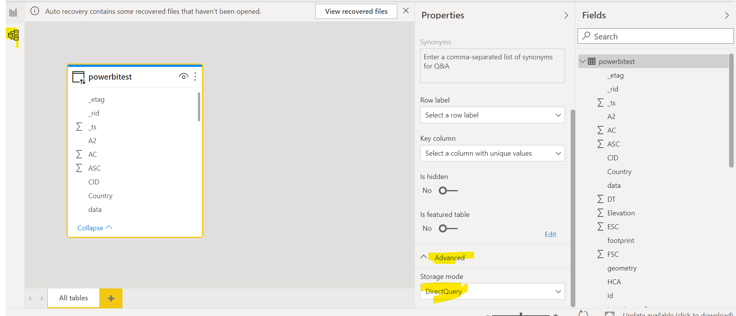

Now in visual I selected gaurage and added property country as we see country count is 1572

Now we will publish this to powerbi workspace and will see how the country code automatically change once user add country to cosmodb

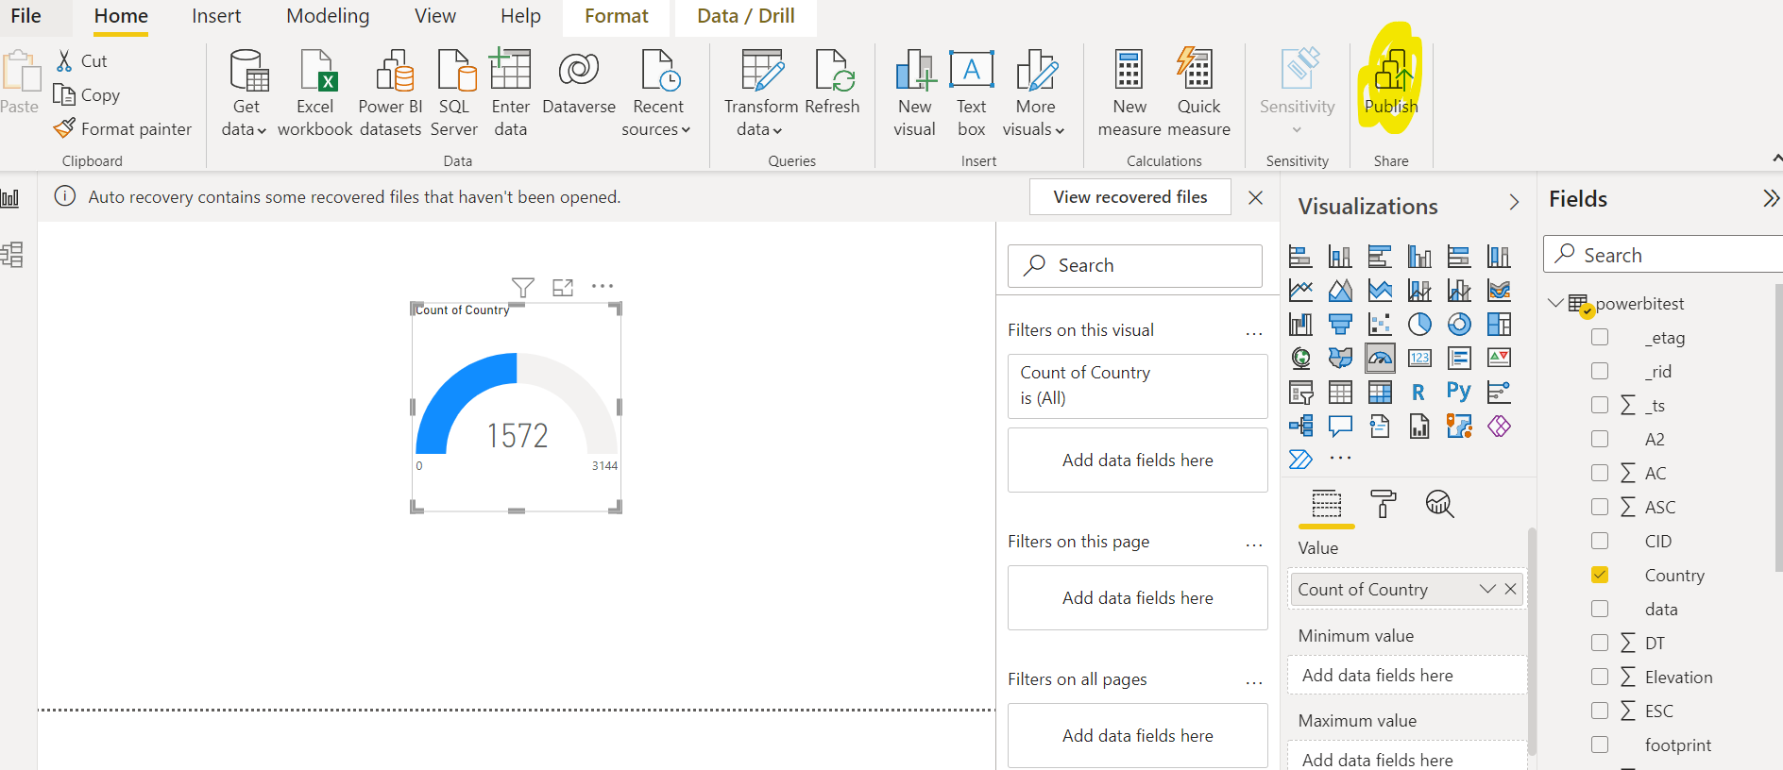

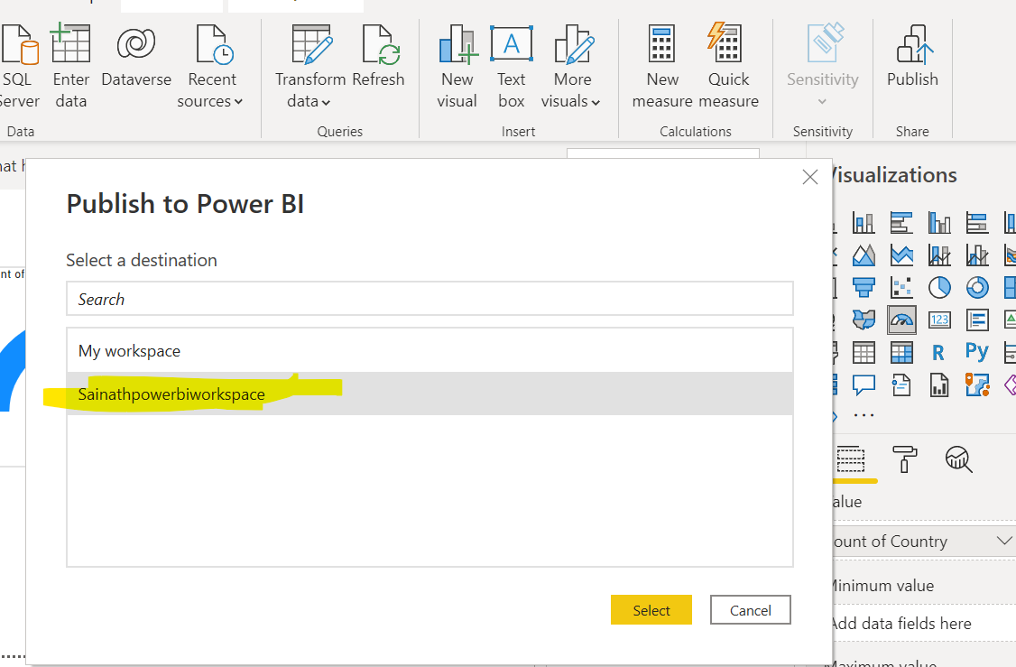

Select your workspace which we have created in powebi and selcect it will publish

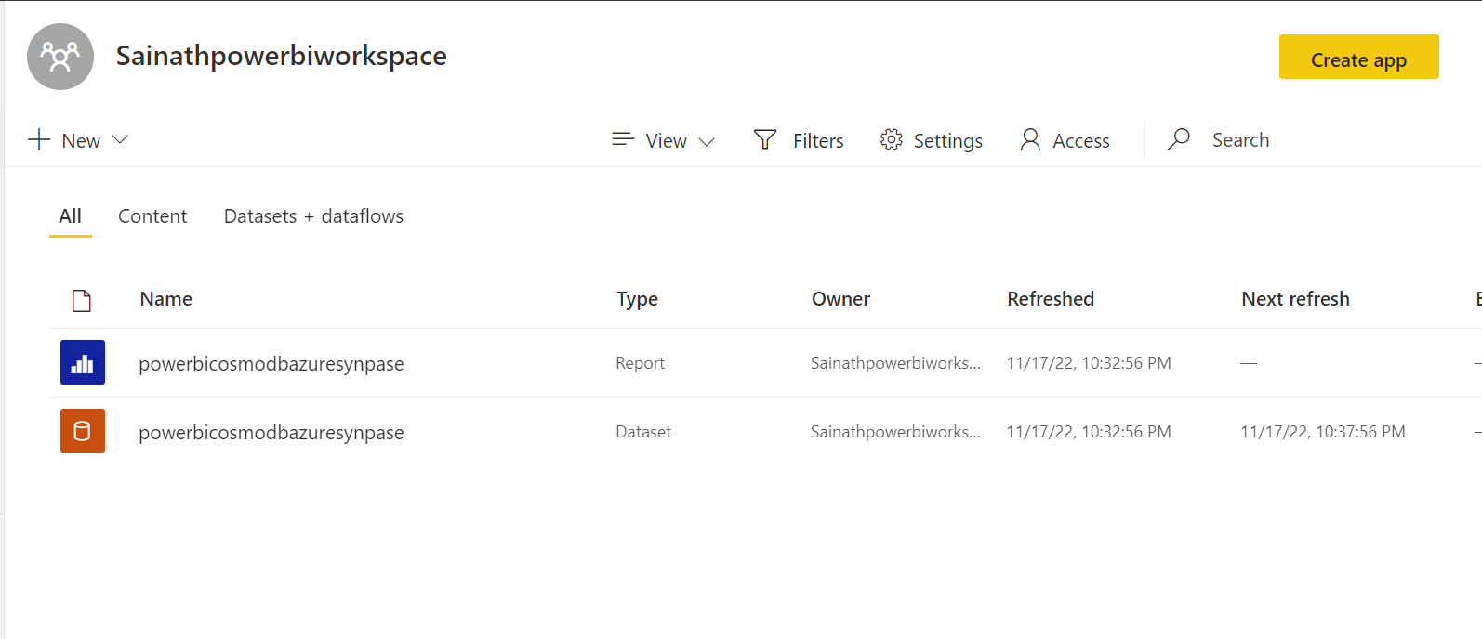

Open report

Incase if you see this error enter the datasource name this error will go away

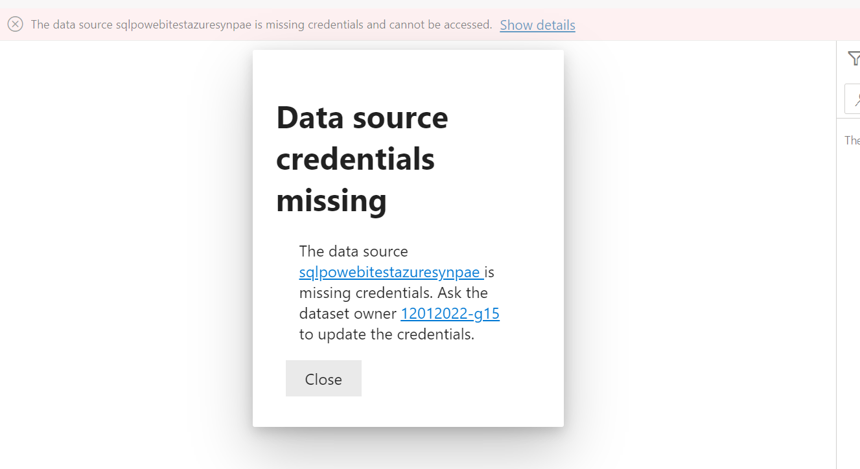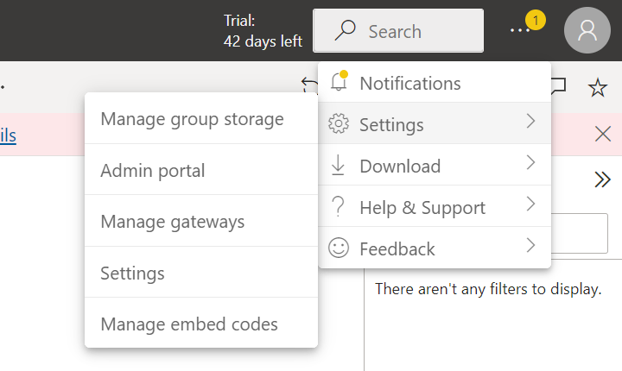

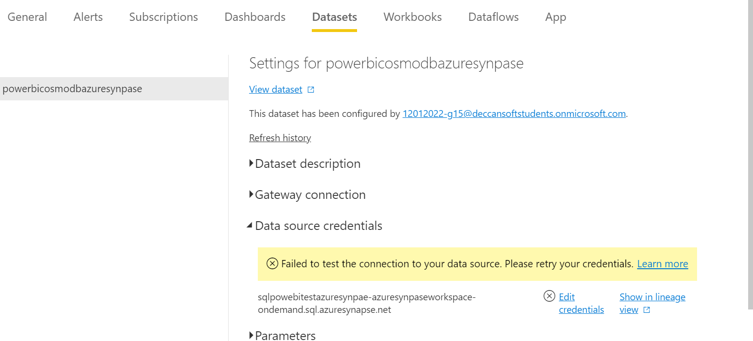

Enter the synpase sqluseradmin and password which we have created

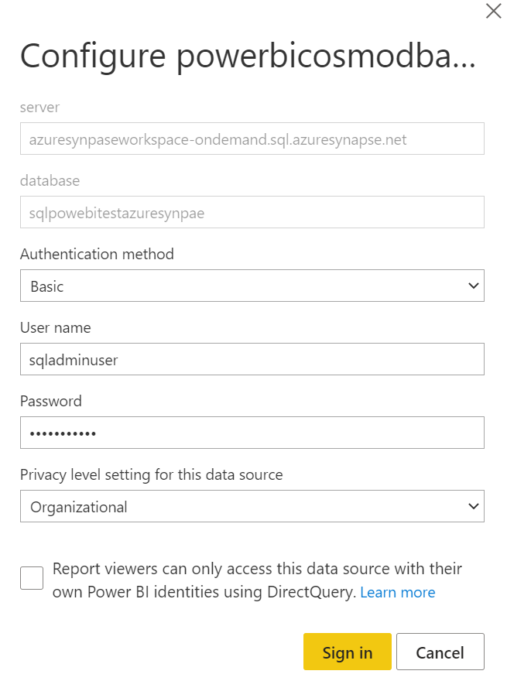

Now go back to powrbi report the report will open

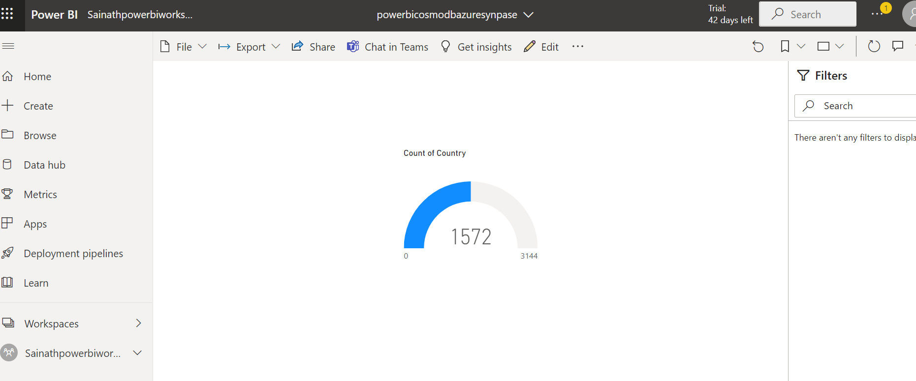

Now azure synpase is connected now we need to add data to cosmodb and make this country count increase automatically from 1572 -1573 with out publish like import technique

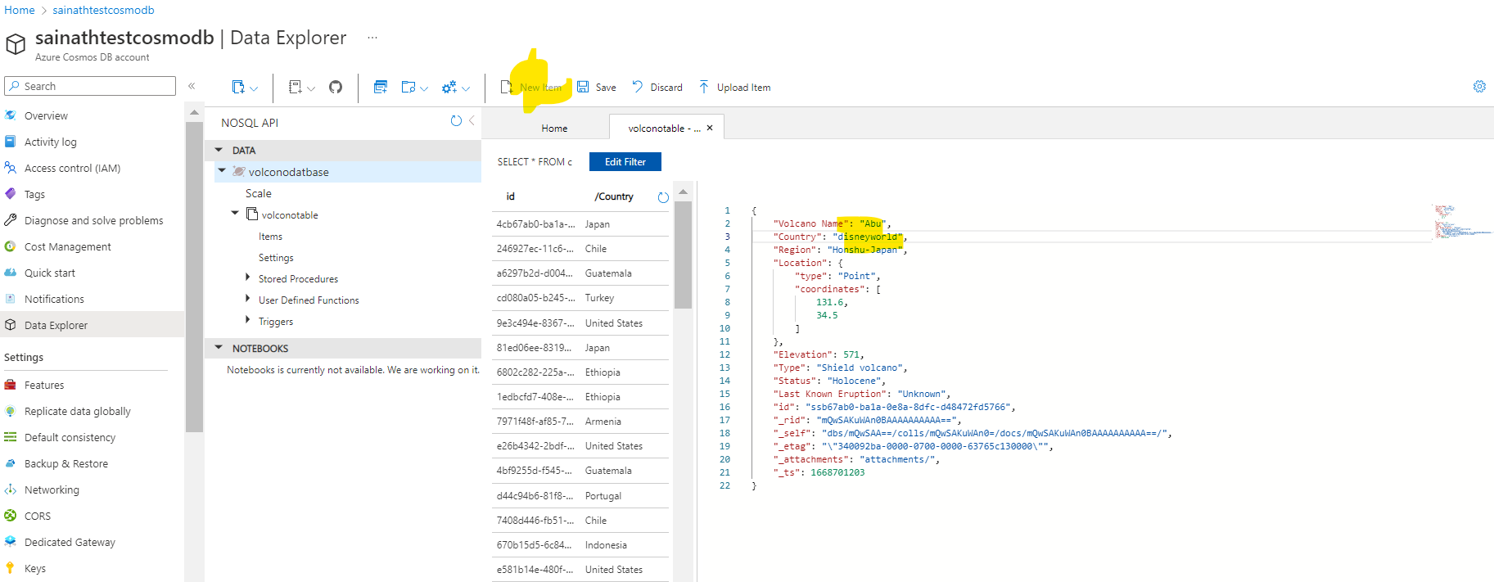

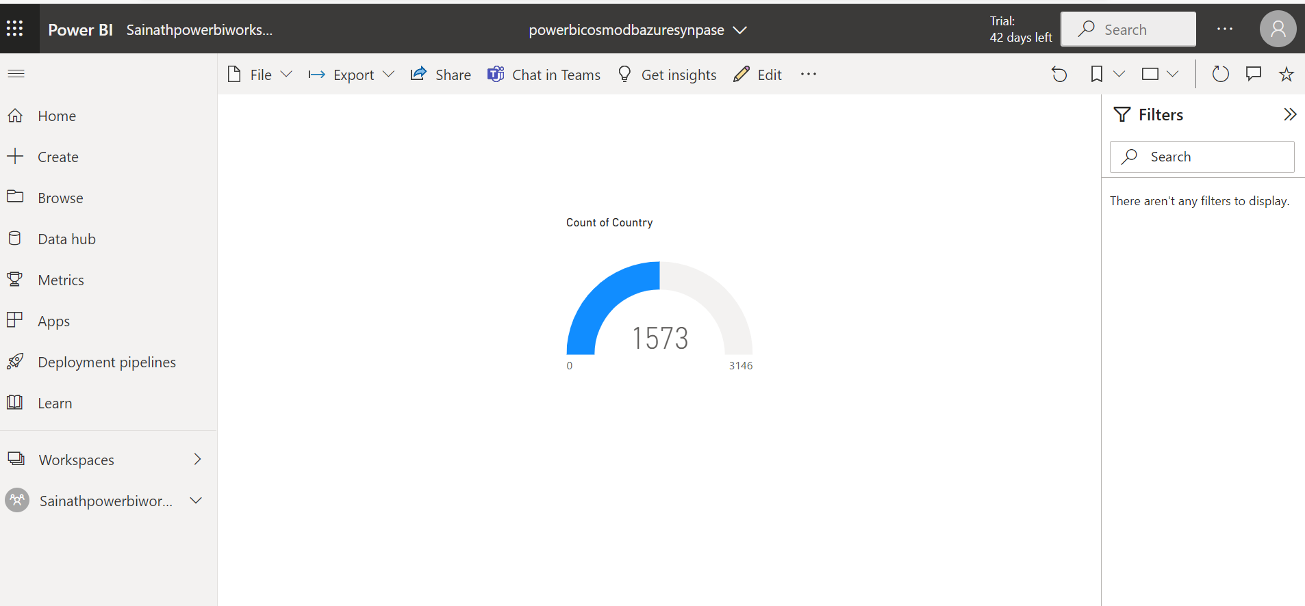

If you want to refresh based on time you can do based on powerbi licences

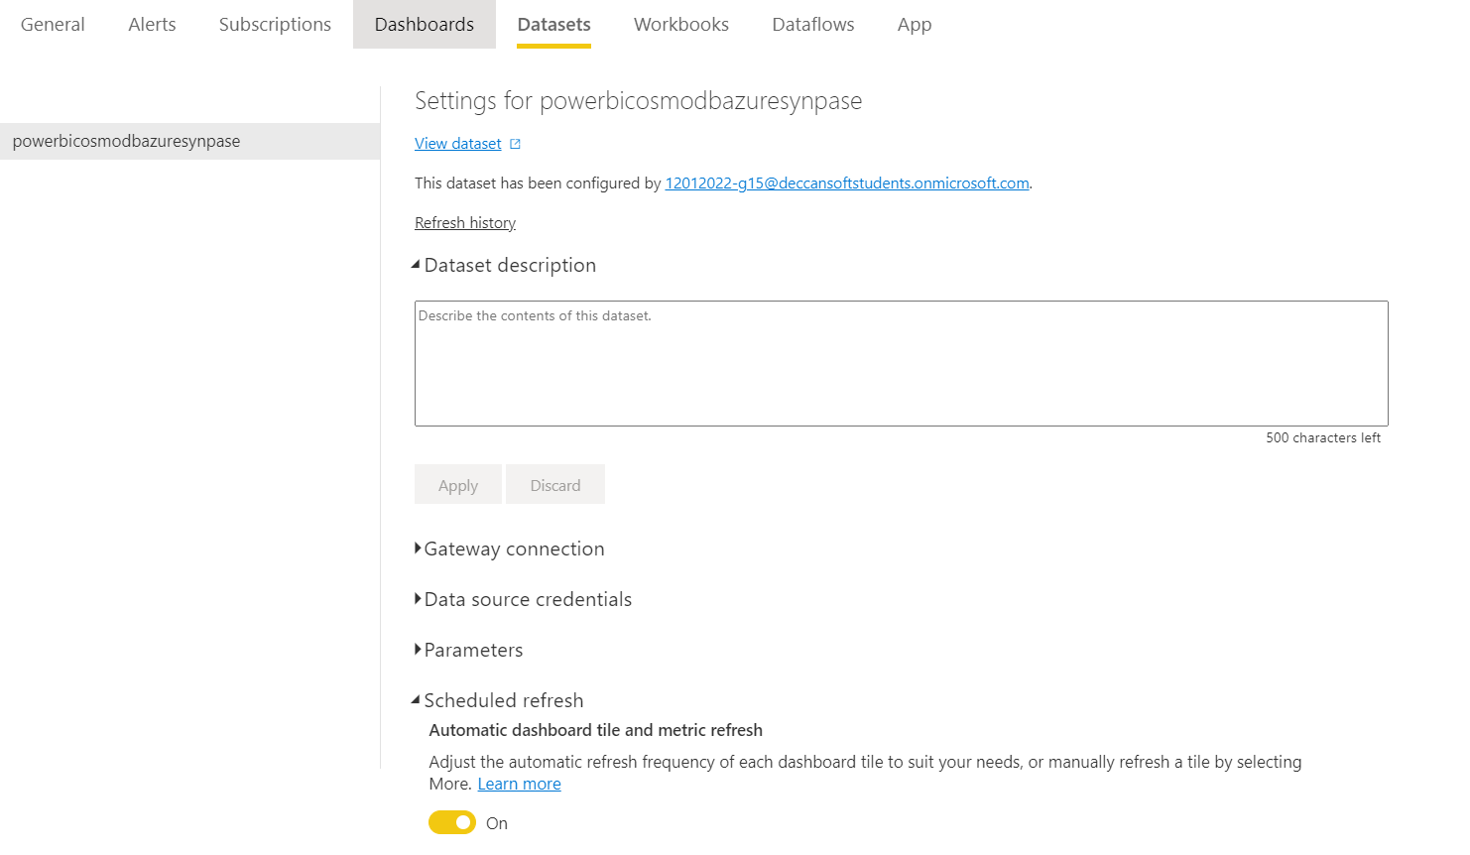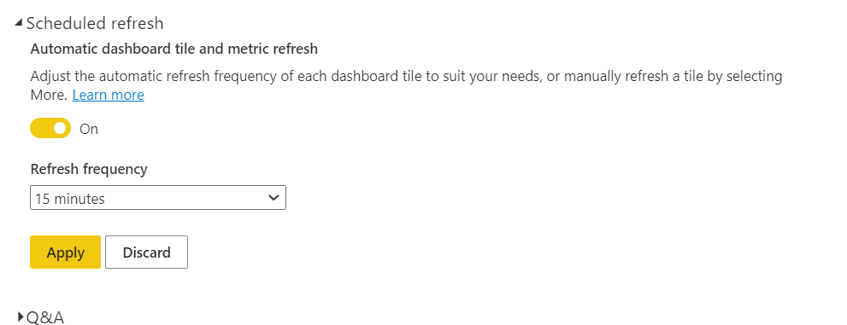

Automatically sleeted refresh time it will get refreshed

---------------------------------------------------